

**S. B. JAIN INSTITUTE OF TECHNOLOGY,**

**MANAGEMENT & RESEARCH, NAGPUR.**

# Pre Lab

**Aim:** Understand the concept of repository, branch, commit, pull request etc. and create a GitHub account. Also add any template of HTML in GitHub repository.

**Name of Student:Roshan Hingnekar**

**Roll No: CS23108**

**Semester/Year: II/I**

**Academic Session:** **2023-24**

**Date of Performance**: **17/01/2024**

**Date of Submission**: **22/01/2024**

**AIM:** Understand the concept of repository, branch, commit, pull request etc. and create a GitHub account.

Also add any template of HTML in GitHub repository.

**OBJECTIVE/EXPECTED LEARNING OUTCOME:**

The objectives and expected learning outcome of this practical are:

* To know the working of Github platform.
* To know how to create account on Github platform.
* Able to add HTML template on Github repository.

**THEORY:**

**What is GitHub?**

GitHub is a code hosting platform for collaboration and version control.

GitHub lets you (and others) work together on projects.

**Repository**

* A GitHub repository can be used to store a development project.
* It can contain folders and any type of files (HTML, CSS, JavaScript, Documents, Data, Images).
* A GitHub repository should also include a licence file and a README file about the projects.
* A GitHub repository can also be used to store ideas, or any resources that you want to share.

**Branch**

* A GitHub branch is used to work with different versions of a repository at the same time.
* By default, a repository has a master branch (a production branch).
* Any other branch is a copy of the master branch (as it was at a point in time).
* New Branches are for bug fixes and feature work separate from the master branch. When changes are ready, they can be merged into the master branch. If you make changes to the master branch while working on a new branch, these updates can be pulled in.

**Commits**

* At GitHub, changes are called commits.
* Each commit (change) has a description explaining why a change was made

**Pull Requests**

* Pull requests show content differences, changes, additions, and subtractions in colors green and red).
* As soon as you have a commit, you can open a pull request and start a discussion, even before the code is finished.

**Steps to install Github:**

* Visit the download page for GitHub Desktop.
* Click Download for Window.
* In your computer’s Downloads folder, double-click the GitHub Desktop zip file.
* After the file has been unzipped, double-click GitHub Desktop.
* GitHub Desktop will launch after installation is complete.

**How to create account on Github?**

* Open https://github.com in a web browser, and then select Sign up.
* Enter your email address.
* Create a password for your new GitHub account, and enter a username, too. ...
* Verify your account by solving a puzzle. ...
* After you verify your account, select the Create account button.

**OUTPUT/SCREENSHOTS:**

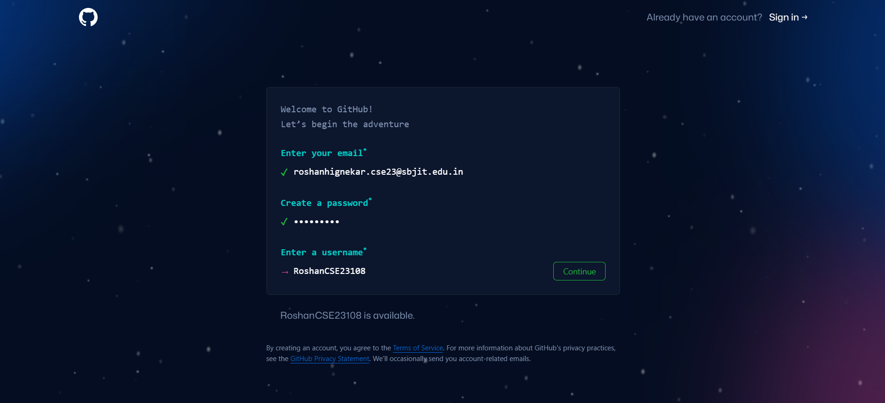

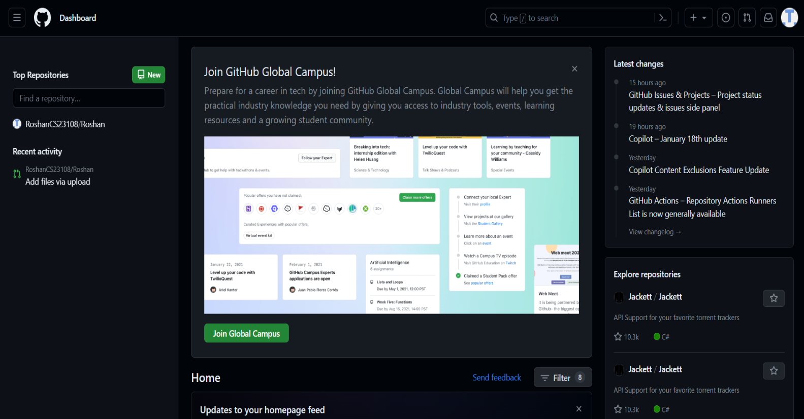

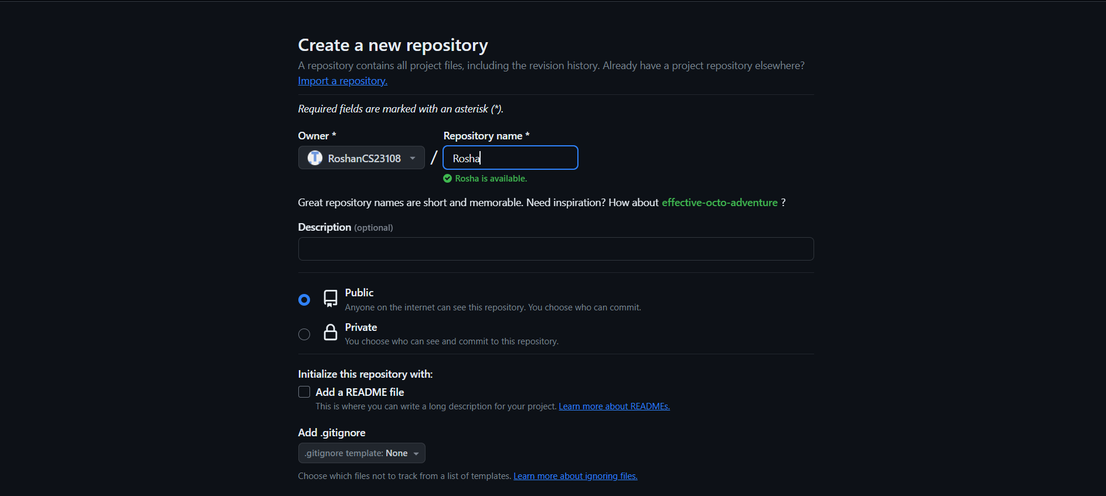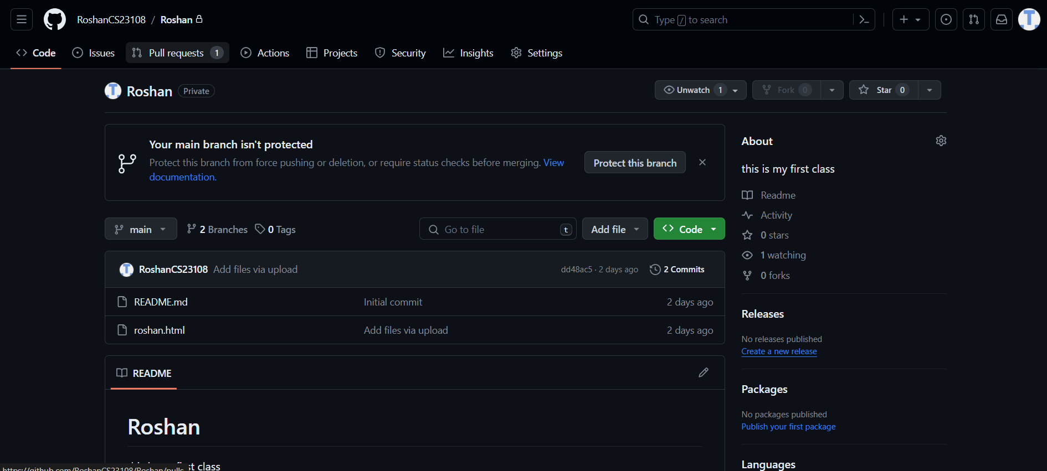

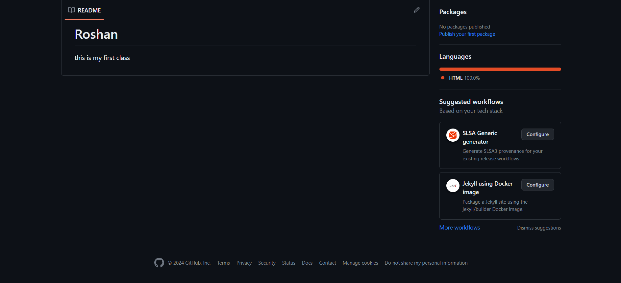

**CONCLUSION:**

Hence we concluded that how to create a GitHub account and Understood the concept of repository, branch, commit and pull request.Also how to add any template of HTML in GitHub repository

**DISCUSSION QUESTIONS:**

* 1. What is Github?
  2. Define repository. How can you create repository on Github?
  3. Explain pull request?
  4. How much space do we get on Github?
  5. What are the benefits of Github over other platforms?

**REFERENCE:**

<https://github.com/simplilearn-github>[https://www.youtube.com/watch?v=iv8rSLsi1xo.](https://www.youtube.com/watch?v=iv8rSLsi1xo)

<https://www.codewithharry.com/videos/git-tut-beginners-hindi-1/>